**Name : Sahil Agrawal**

**Roll no. : 20CS3054**

**Project : Background Subtraction using MATLAB**

**Short Description**

In my project, I will use two images. First image is any picture or photograph that contains a background as well as a foreground. Example: The image can be a group of people standing near a building, here group of people is foreground and the building behind them is background. The second image contains exactly the same background as of the first image that is the image of a building .

**First image that contains both Foreground as well as Background.**

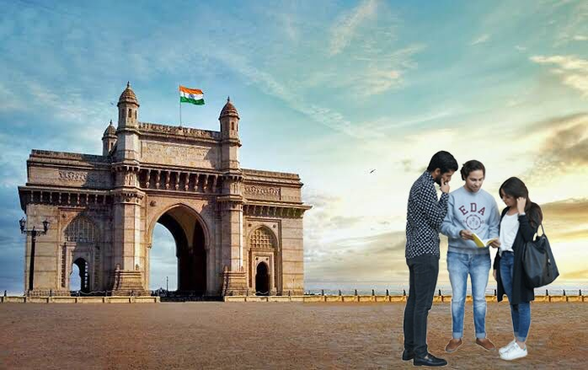

**Second Image that contains only Background**

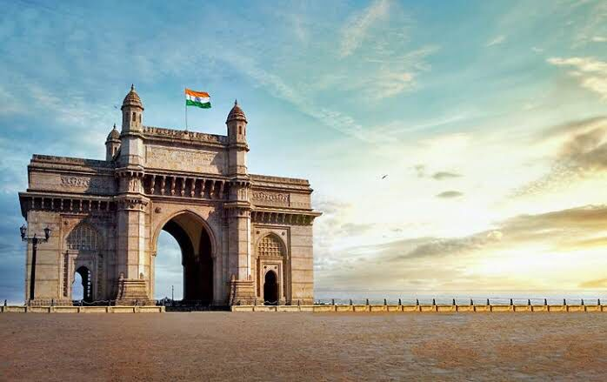

After taking these two images ,my objective is by using some code, I will extract the foreground that is , the group of people in this case .

**FLOW CHART:**

**INPUT**

**( ORIGINAL IMAGE AND BACKGROUND IMAGE )**

**DISPLAY ORIGINAL IMAGE AND BACKGROUND IMAGES**

**ON THE SCREEN**

**CONVERT ORIGINAL AND BACKGROUND IMAGE INTO**

**HSV IMAGE**

**SUBTRACT BACKGROUND AND CONVERT THE OUTPUT IMAGE**

**INTO GRAY IMAGE**

**CONVERT THE GRAY IMAGE INTO BINARY IMAGE AND APPLY**

**FILTER TO THE BINARY IMAGE**

**DISPLAY THE FINAL FILTERED BACKGROUND IMAGE ON**

**THE SCREEN**

**Main Challegenges**

My initial plan was to store the above two images in two different variables using a predefined function of MATLAB and just subtract them to get my required output. After running the code, I got the following output:

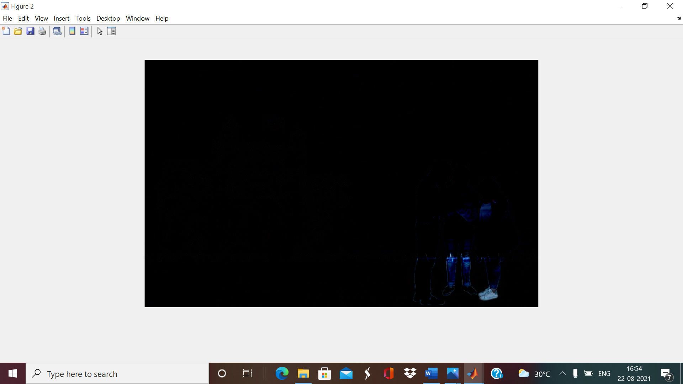

In the above image, we can see some light blue patches at the bottom right corner of a black background, this was not the output I expected and the reason is that I just subtacted two RGB images and black background is showing that the part of image that was same in both the images got subtacted and it also had some effect on the foreground as it decreases the intensity and we can’t see the foreground clearly.

**How I overcome my challenge**

I, then , began to learn about different kind of images such as HSV , Gray Image and binary image and how I can convert one form to other form of image.Then , I subtracted two binary images and I get the following output:

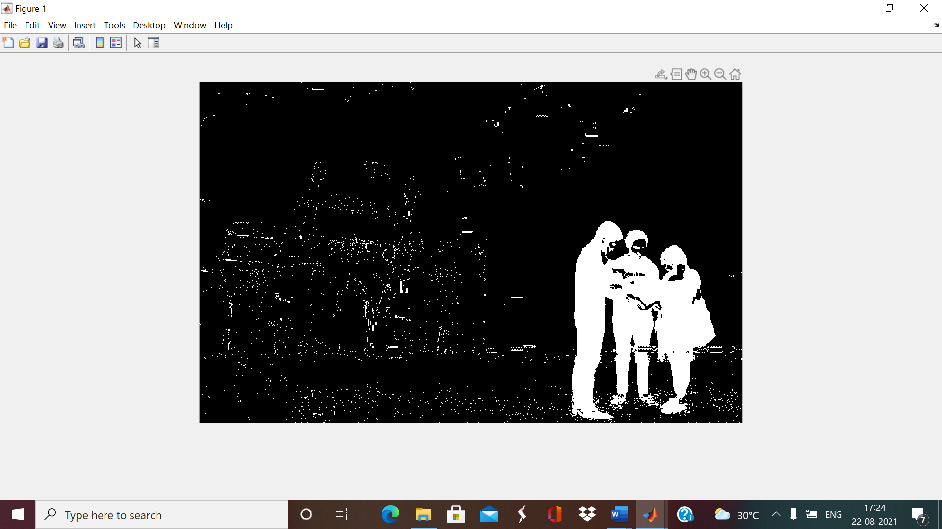

Above binary image shows the foreground (group of people) but it has some noise which I wanted to be removed . The noise , here, is white dots distributed randomly on the entire background.

I started learning how it can be removed and during that course I learnt about image filters and how they work and I found that median filter2 is best for removing such type of noise fom a binary image

I applied the median filter in the above subtracted image and got the output shown below:

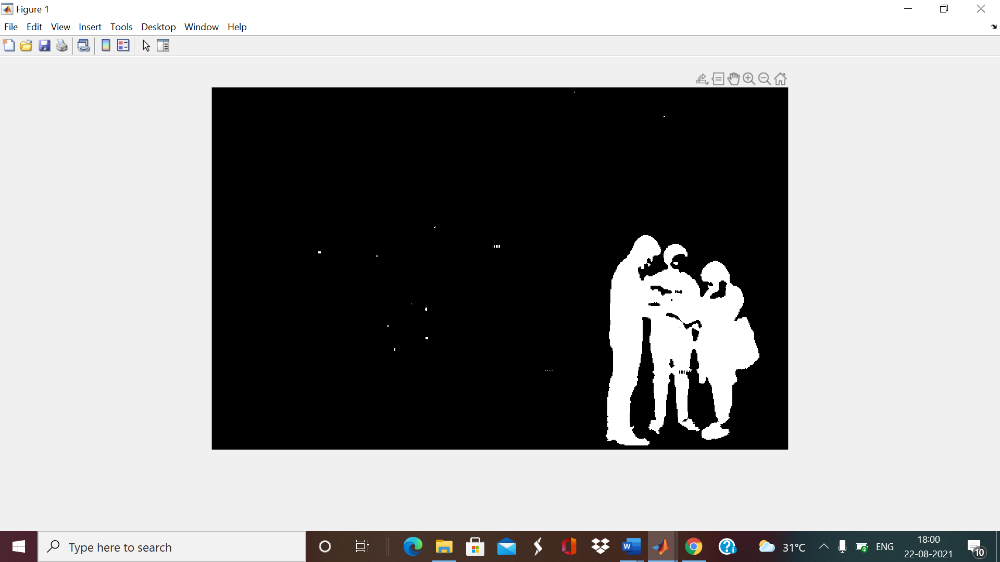

Above image shows the foreground extracted from an image and it is also very clear as all the noise has been removed.

**Frontend**

My project will display all the four images which are:

1. Original Image
2. Image of Background
3. Subtracted image without Filter
4. Subtracted Image with Filter

Screenshot of final output:

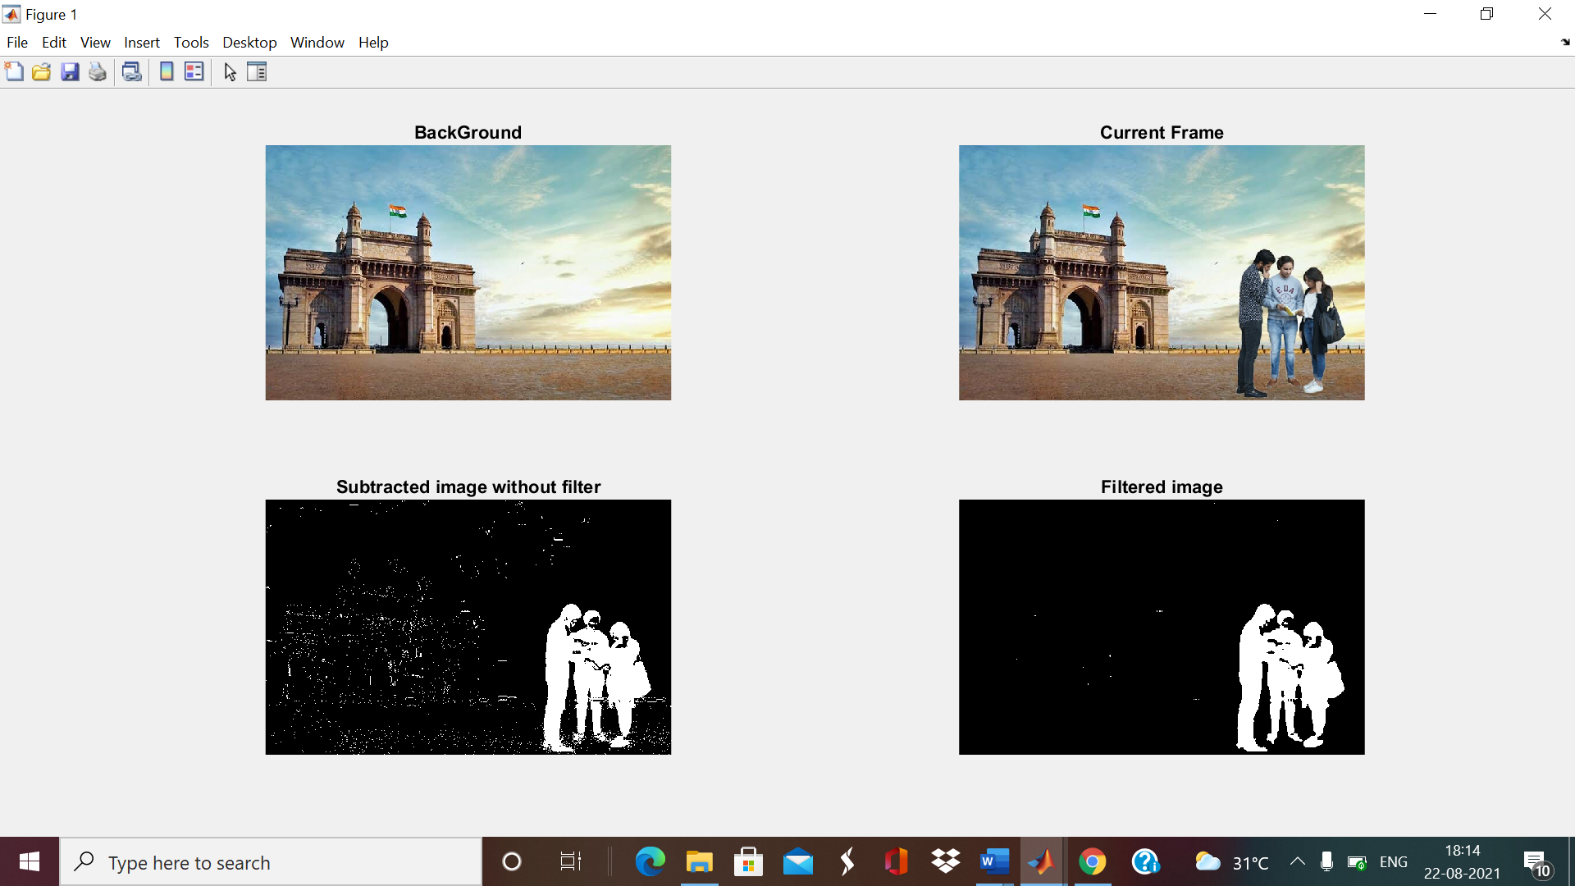

**Backend**

It will contain code for conversion of images from RGB to Binary Image and for subtraction of background from the original image and then code for application of median filter and finall to display all the four image in one frame .

**Database**

The database required in this project are that two images one that contains both background and second with only background same as in image one.

**Use of this project in The Real World**

Image Background Subtraction can be used in urban traffic surveillance, for free parking detection , in visual observation of animals and insects behaviour, it can also be used to extract foreground then add into another background,visual observation of natural environment such as to detect some forign objects like water bottles , floating wood in river and oceans, in many sports like soccer and tennis with “Hawk-Eye” where decisions needed to be made quickly .